How can TATA create positive brand awareness around its commercial vehicles in South Africa (towards increasing sales)?

Tata’s mission statement.
‘‘To improve the quality of life of the communities we serve globally through long-term stakeholder value creation based on Leadership with Trust.’’
Through the use of Tata’s mission statement the presentation, will answer the question through referring to the three key elements communities, long-term and trust.

Dilemma
Recently they have been many problems in various parts of South Africa regarding public transport. The public transport system has not been running efficiently and as a result nationwide strikes have been occurring with the public demanding more efficient bus system. In the Mangaung area the public are tired as they need public buses to go to and from work and rely on them to go everywhere. Most of the public use public transport and choose to use buses as they are the cheapest form of transport. However this lack of efficient transport is causing problems for many especially in regards to work and shifts an example of those who are affected in this case are those who work in hospitals.
Hospitals are ‘’health care institutions providing patient treatment with specialized medical and nursing staff and medical equipment’’. They operate 24 hours and work in shifts. It is crucial that a smooth transition is done between the shifts as many lives depend on it. This is where TATA comes in.

Market Analysis and gap identification.

Introduction
Public transport is a dependant from of transportation that a large percentage of the population uses on a daily bases to get them to their destination. By Cambridge dictionary definition it is ‘’ a system of vehicles such as buses and trains that operate at regular times on fixed routes and are used by the public’’ (Cambridge Dictonary , 2015). The crucial phrases being ‘’regular time’’ and ‘used by the public’, these phrases emphasise the importance of public transport to operate efficiently as people from various demographics (the public) rely on it.
However this is not the case in the Mangaung. Recent media reports show that the people of Mangaung are not satisfied with the bus public transport system, attributable to a lack of efficiency.

Market research
The public bus industry is facing difficulties in recovering from recent strikes from workers due to demands of a 15% increase. This has caused loss of money for business, although both large and small businesses have suffered the consequences, smaller businesses are feeling it more financially. This is a problem as it causes changes in consumer preferences. Consumers want more reliable busses, reason being they feel some of the main bus service companies are sticking to schedule times and providing well-conditioned buses.

Market Gap
The marketing gap in the scenario would be an unmet consumer need and service. Gaps in the market create opportunities for companies to reach an untapped market.
The types of gaps that are present are:
- Value gap- as there is a lack of buses that hold value with the people in terms of efficiency.
- Time gap- in terms of the manufacturing of buses and the companies that render the service.
The types of gaps are identified through backyard evidence as companies need more innovative and cost effective solutions. The information gathered through media reports indicates that there is an unfulfilled market in Bloemfontein for bus rendering services to Hospitals.

Market attractiveness
Market factors
- Size of market – Large; buses are the cheapest mode of transport and the most used form of public transport in Bloemfontein.
- Current customer loyalty - Customers are not loyal to current providers as there are not in partnership with any hospitals and due to lack of efficiency.
- Seasonality of demand - All year round

Economic and technology factors
- Investment intensity – Medium; only drivers and people to organise routes are needed
- Ability to pass through effects of inflation – High; transport is a basic necessity to those who live too far to walk; consumers will be relatively inelastic to inflation.

Target Market.

The Universitas Private Hospital was identified as the target market. Qualitative research was done through an interview and questionnaire (Appendix 1) with a representative of the Universitas Private Hospital. Through this research we managed to identify a few facts that represented at least 90% of the employees. We then created a customer profile to represent the majority of the stuff.
Customer Profile


Name: Nurse Boitumelo.
Age: 50 years old
Where she lives: Rocklands
Main source of Transport: Public Transport
How much she spends on transport: R1500+/-
Are daily transport costs covered by employee: No
Are emergency transport costs covered by employees: Yes

Strategy.
Rendering a bus service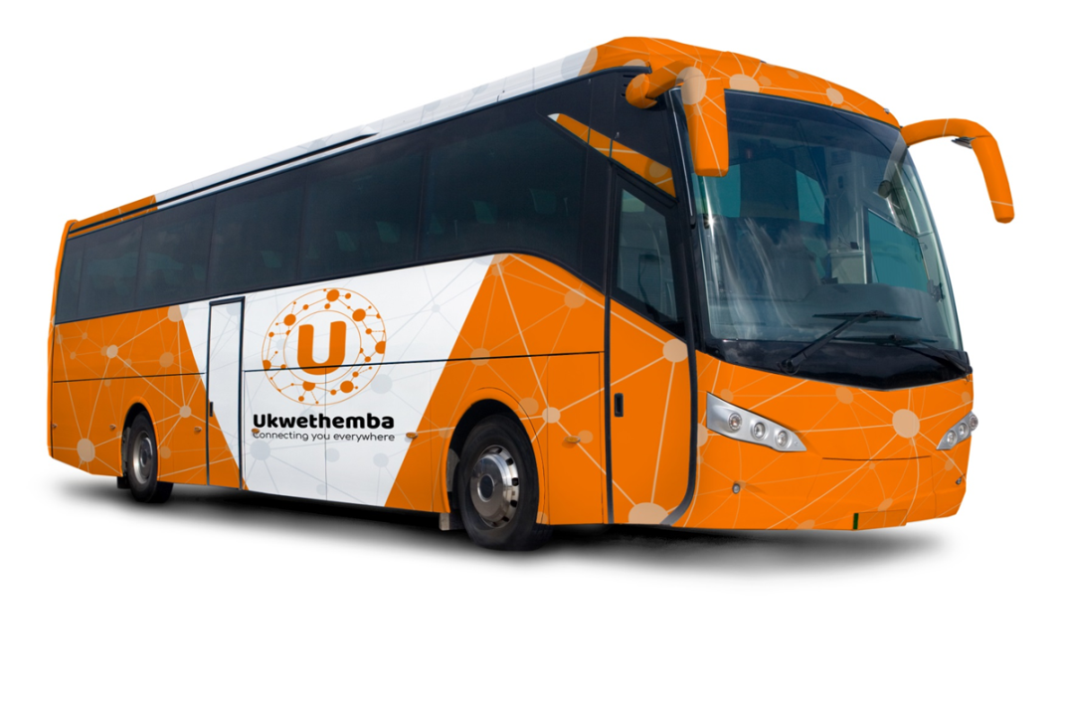
The strategy is for Tata to start rendering its own bus service. Through this they will render the bus service as a social development project under the brand name Ukwethemba. The rendering of the bus service is directly linked to accomplishing Tata’s mission statement. Firstly with the name Ukwethemba which means Trust in English. The purpose of this social development project is for Tata to go beyond just selling products and services instead they will increase awareness and sales around their buses by rending a service and knowing the people that use their products. They will be solving a problem in the community by providing a reliable bus system for the stuff of Universistas Private Hospital to get to and from work on time. This will encourage community involvement and cause long-term relationships for Tata with the hospitals and its stakeholders.
The design and the logo of the bus were made specifically for Tata. The slogan being ‘connecting you everywhere’ to showcase the efficiency of the Tata buses. The colour orange as it draws attention and is associated with joy and sunshine.

How will it work?
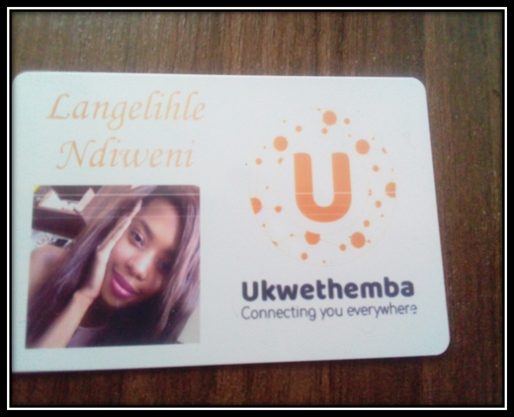
There will be a card system that will be used to identify employees. It will work in terms of swiping the card when employees enter the bus this will connect with the hospitals system through Wireless connection. Firstly for purposes of the system to let the hospital know which employees would have gotten into the bus and to ensure they are not short staffed and that every employee who is meant to be on that shift has boarded the bus. It is also for the purpose of accounting, when Tata sends its monthly statement to Universitas Private Hospital it will also send the employee card information that will show which employees got into what bus on what day. It will also be used for Tata to get to know its communities it will know the name, age and gender of the staff members. As a result the bus driver may say happy birthday on behalf of Tata on an employees birthday, this will be a form of Tata connecting with the community and step towards building long term relationships.
The bus drivers will have a class C drivers licence which allows a mini-bus, a bus or a good vehicle. The bus drivers will be required to have at least 2 years’ experience with bus driving a police clearance, recommendation letters and background check will be required before they get the job. The vehicles will stay in the Universistas hospital parking that has 24 hours security the keys will be kept at the reception in case of emergency so that the bus drivers have access to the vehicles.

Route and Daily Schedule.
The route that will be used will be 13km between the hospital and Rocklands. It will take approximately 23 minutes to get from one point to another. However this calculation does not consider other variables that may change the time such as traffic, weather or accidents on the road. As a result we will use two buses to have an extra 37 minutes on each trip to accommodate for uncontrollable variables. A sample of the daily schedule is listed below and a visual illustration of the route is below.
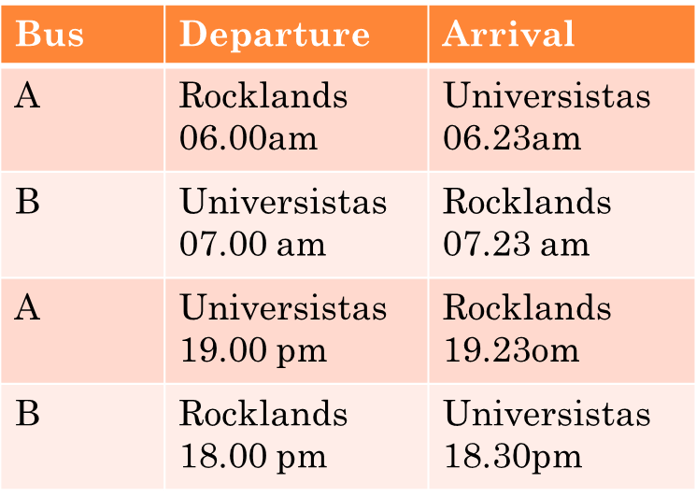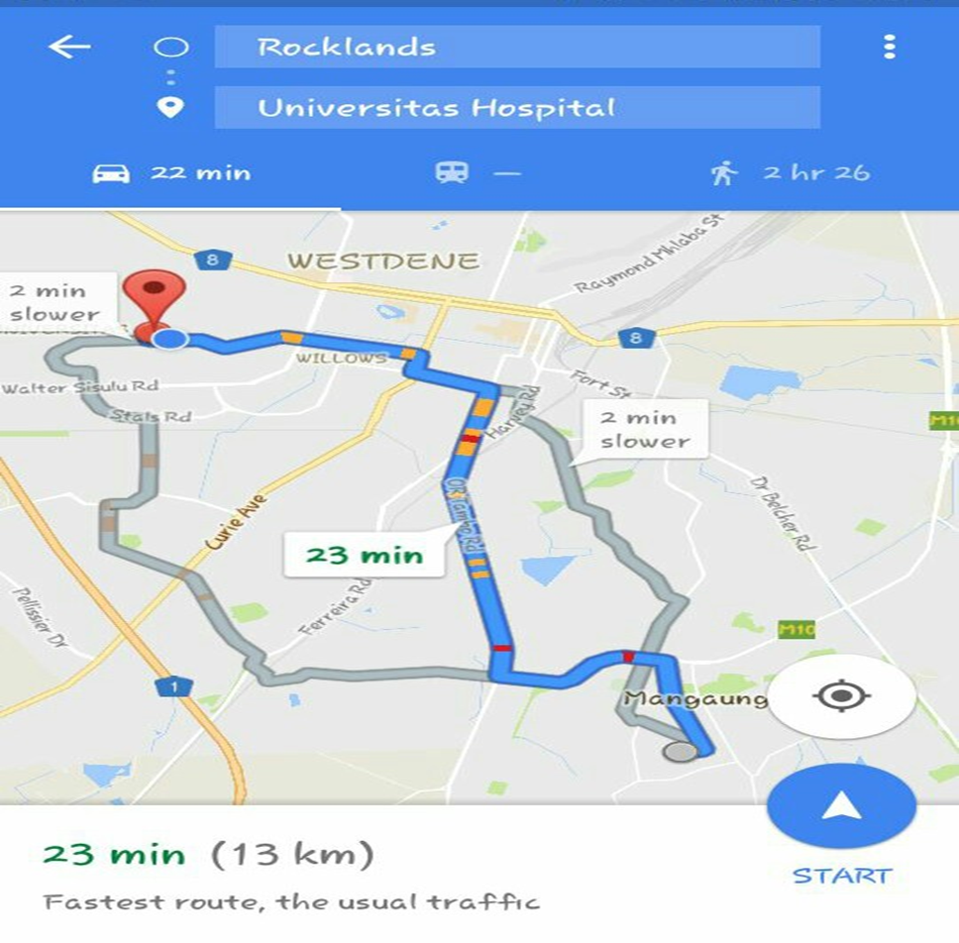

Uniform.
The uniform and logo consist of the same colour. The bus drivers will wear this uniform in order to maintain brand consistency.
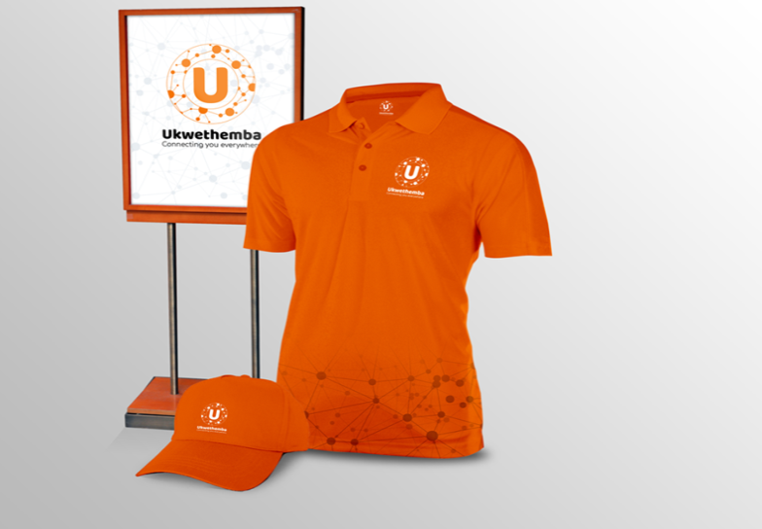

Contingency Plan.
Anti-social Alex is our contingency plan. He is a 26 year old third year student who has a class B and C drivers licence who lives at Campuskey (20 walking steps from the hospital). He worked as a bus driver for 3 years to raise funds to go to university. He does not drink or go out. He has few friends outside his study group. He spends his spare time studying in his room and watching movies. As a result we can count on Anti-social to be available to be a backup bus driver if one of our drivers falls sick or to be available on a Friday night at 2 am and be fit to drive and pick up employees from their homes. If it’s a hectic night at the emergency room and they need more staff. If they are less than four employees that need to be picked up he will use the Tata Bolt.
Using Anti-social Alex is another way of Tata being involved in the community by employing the youth.
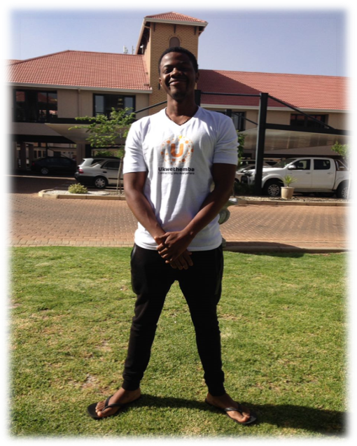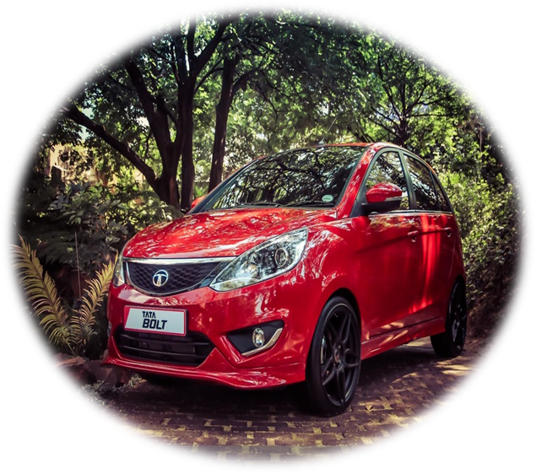

Financials

Income statement for Tata motors for the month of October 2017.

Income: R
Service rendered (R1200 X 42 employees) 50 400
Emergency transport covers 2500
Total income 52 900

Expense:
Salaries: Bus drivers (R5000 X 2 drivers) 10 000
Part-time student 1 500
Fuel: Buses (R7027, 20 X 2 buses) 14 054, 40
Car 1 000
Discount allowed (service rendered) (50 400-47 000) 3400 (29 954, 40)
Net profit 22 954.60

The purpose of the income statement is to show how much the organization will generated during a reporting period and to show the operating profit.
When compiling this Income Statement the following factors were taken into account, fuel cost at the nearest Caltex fuel station, the distance between the destinations, the engine capacity and the average speed limits to see how much fuel the buses and car would consume on a monthly basis.

Benefits for Hospital.

- The Hospital will now have reliable transport system and will not have to worry about employees being late for their shifts due to lack of transport.
- Transport system that operates 24 hours, since the hospital operates 24 hours per day it is only right that they have a 24 hour transport system at their disposal.
- Transport will be part of employee benefits, this will improve moral and motivate employees to work harder.

Benefits for Tata

- Corporate Social responsibility in terms of social development project, this will help Tata to get involved with the local community ,building long-term relationships with the hospital and its stakeholders as a result people will not only be aware of Tata buses but will trust the buses and Tata as a brand. This will result in increase of sales for buses and other Tata products.
- Can be implemented nationwide, this social development project may be implanted in other parts of South Africa such as Gauteng and Kwazulu Natal
- Can be implemented into different sectors, apart from the Hospital sector Tata may begin to render buses full time to the public and compete against companies nationwide such as Putco and Metro in the Gauteng area.

